# Limits and derivatives

## Difference quotient

Assign x and delta x (h):

Formula for the difference quotient:

Factor out 1/h to get rid of the h denominator:

Find Greatest Common Denominator (GCD) and apply that to each of the numerators:

Assign to delta x (h) a value very close to zero (limit as x -> 0):

Then put that into expression above:

And that matches our derivative!

## Removable discontinuity

This gets very close to 1 as limit x->0, so we say there’s a removable discontinuity at x = 0:

This gets very close to 0 as limit x->0, so we say there’s a removable discontinuity at x = 0:

## Infinite discontinuity

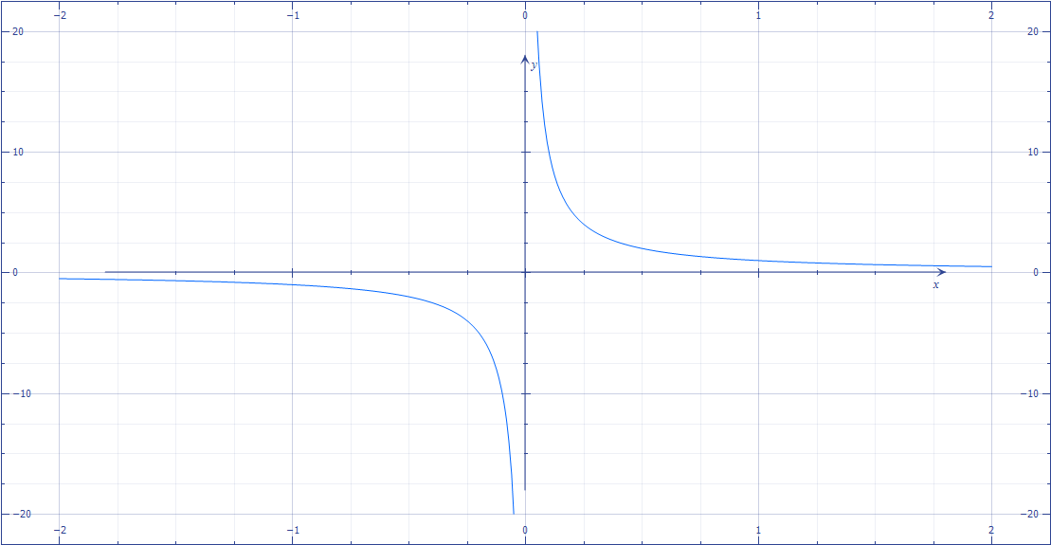

The derivative of this is:

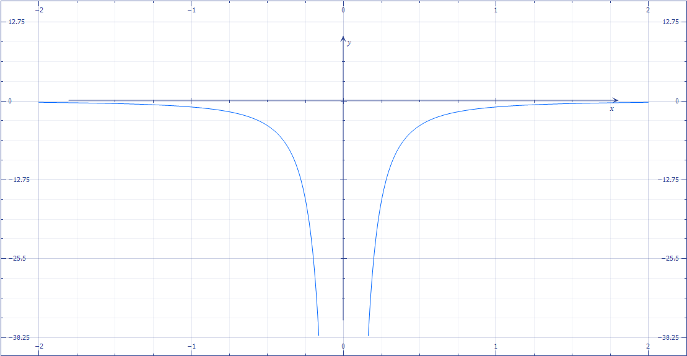

The derivative of an odd function always gives an even function!

## Other (“ugly”) discontinuities

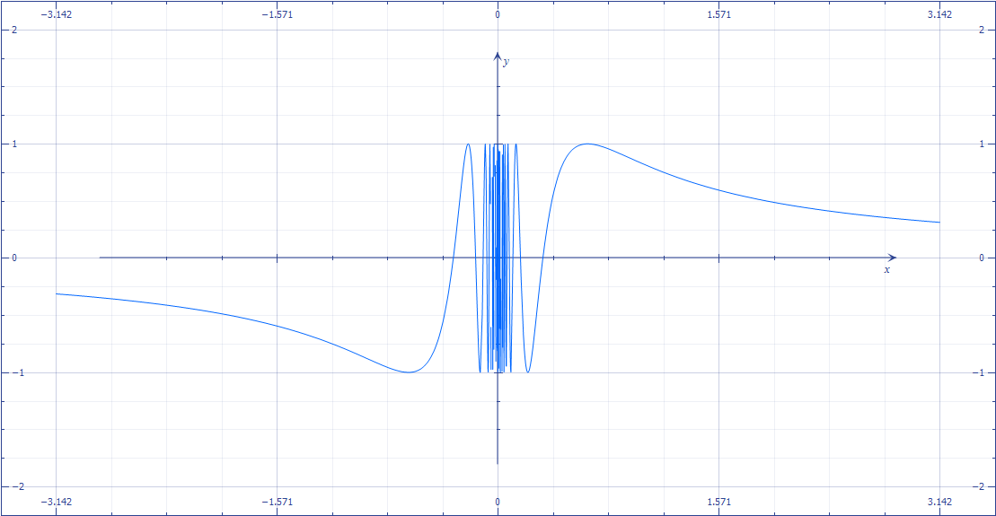

There is no left or right limit in this case, the function is infinitely oscillating.

## **Theorem**

Differentiable = Continuous. If f is differentiable at x0, then f is continuous at x0.

## **Proof**

Limit x->0, f(x)-f(x0) = 0